Задача "Обновление clamav на серверах из скоупа ЦБ" (https://jira.tcsbank.ru/browse/IN-1637)[Петрова Юлия][назначил Александров Алексей].
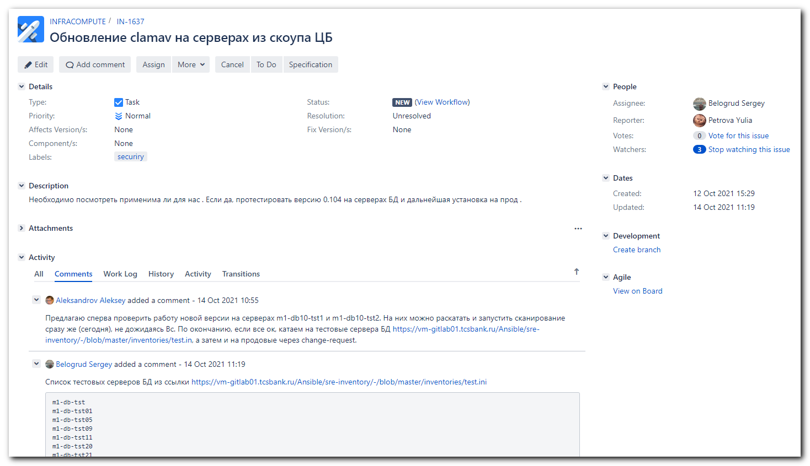

https://tinkoff.slack.com/archives/D014Z6R14SD/p1634222410000100
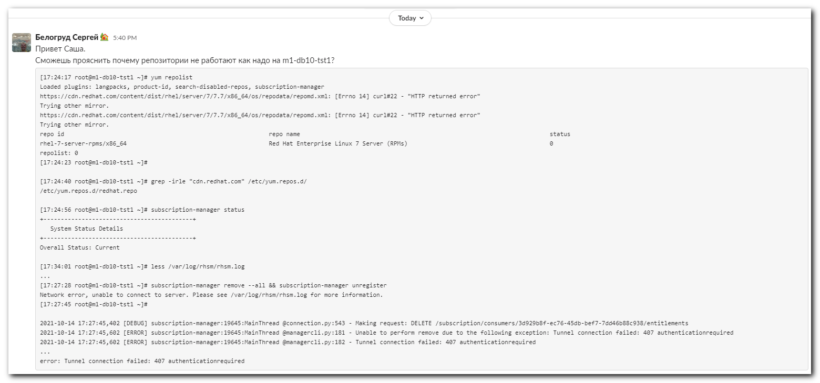
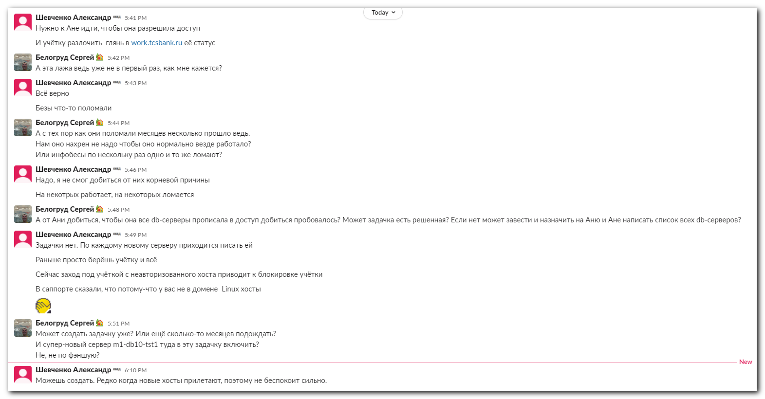

Oct 14, 2021

[17:24:17 root@m1-db10-tst1 ~]# yum repolist
Loaded plugins: langpacks, product-id, search-disabled-repos, subscription-manager
https://cdn.redhat.com/content/dist/rhel/server/7/7.7/x86_64/os/repodata/repomd.xml: [Errno 14] curl#22 - "HTTP returned error"
Trying other mirror.
https://cdn.redhat.com/content/dist/rhel/server/7/7.7/x86_64/os/repodata/repomd.xml: [Errno 14] curl#22 - "HTTP returned error"
Trying other mirror.
repo id repo name status
rhel-7-server-rpms/x86_64 Red Hat Enterprise Linux 7 Server (RPMs) 0
repolist: 0
[17:24:23 root@m1-db10-tst1 ~]#
[17:24:40 root@m1-db10-tst1 ~]# grep -irle "cdn.redhat.com" /etc/yum.repos.d/
/etc/yum.repos.d/redhat.repo
[17:24:56 root@m1-db10-tst1 ~]# subscription-manager status
+-------------------------------------------+
System Status Details
+-------------------------------------------+
Overall Status: Current

#
# Usual method doesn't work.
[17:27:28 root@m1-db10-tst1 ~]# subscription-manager remove --all && subscription-manager unregister
Network error, unable to connect to server. Please see /var/log/rhsm/rhsm.log for more information.
[17:27:45 root@m1-db10-tst1 ~]#

[17:34:01 root@m1-db10-tst1 ~]# less /var/log/rhsm/rhsm.log
....
2021-10-14 17:27:45,402 [DEBUG] subscription-manager:19645:MainThread @connection.py:543 - Making request: DELETE /subscription/consumers/3d929b8f-ec76-45db-bef7-7dd46b88c938/entitlements
2021-10-14 17:27:45,602 [ERROR] subscription-manager:19645:MainThread @managercli.py:181 - Unable to perform remove due to the following exception: Tunnel connection failed: 407 authenticationrequired
2021-10-14 17:27:45,602 [ERROR] subscription-manager:19645:MainThread @managercli.py:182 - Tunnel connection failed: 407 authenticationrequired
...
error: Tunnel connection failed: 407 authenticationrequired

[18:21:52 root@m1-db10-tst1 ~]# egrep -e "^proxy_hostname|^proxy_port|^proxy_user|^proxy_password" /etc/rhsm/rhsm.conf
proxy_hostname =proxy.tcsbank.ru
proxy_port =8080
proxy_user =rhsm_user
proxy_password =****
[18:21:54 root@m1-db10-tst1 ~]#

# Here I found solution.
# https://access.redhat.com/solutions/228883
#

[17:56:14 root@m1-db10-tst1 ~]# subscription-manager clean
All local data removed
[17:58:57 root@m1-db10-tst1 ~]# subscription-manager remove --all
0 subscriptions removed from this system.
[17:59:29 root@m1-db10-tst1 ~]# subscription-manager unregister
This system is currently not registered.
[17:59:44 root@m1-db10-tst1 ~]#

[18:00:46 root@m1-db10-tst1 ~]# yum clean all
Loaded plugins: langpacks, product-id, search-disabled-repos, subscription-manager
This system is not registered with an entitlement server. You can use subscription-manager to register.
There are no enabled repos.
Run "yum repolist all" to see the repos you have.
To enable Red Hat Subscription Management repositories:
subscription-manager repos --enable <repo>
To enable custom repositories:
yum-config-manager --enable <repo>
[18:00:53 root@m1-db10-tst1 ~]#

# In all .repo files turned on option "enable=0". So, they aren't work.
#
[18:01:24 root@m1-db10-tst1 ~]# yum repolist
Loaded plugins: langpacks, product-id, search-disabled-repos, subscription-manager
This system is not registered with an entitlement server. You can use subscription-manager to register.
repolist: 0
[18:01:28 root@m1-db10-tst1 ~]# vim /etc/yum.repos.d/tcs-epel.repo
[18:02:19 root@m1-db10-tst1 ~]# mkdir -p ~/work/20211014-1802/backup/
[18:02:39 root@m1-db10-tst1 ~]# mv /etc/yum.repos.d/* ~/work/20211014-1802/backup/
[18:03:04 root@m1-db10-tst1 ~]# ls -Alh /etc/yum.repos.d/
total 0
[18:03:19 root@m1-db10-tst1 ~]#

# Then I execute my ansible-role "repository" to install configs to local repository.

[18:06:20 root@m1-db10-tst1 ~]# yum install clamav
Loaded plugins: langpacks, product-id, search-disabled-repos, subscription-manager
This system is not registered with an entitlement server. You can use subscription-manager to register.
Resolving Dependencies

...

Dependencies Resolved

=========================================================================================================================================================
Package Arch Version Repository Size
=========================================================================================================================================================
Installing:
clamav x86_64 0.103.3-8.el7 tcs-epel 433 k
Installing for dependencies:
clamav-filesystem noarch 0.103.3-8.el7 tcs-epel 42 k
clamav-lib x86_64 0.103.3-8.el7 tcs-epel 832 k
clamav-update x86_64 0.103.3-8.el7 tcs-epel 125 k
gnutls x86_64 3.3.29-9.el7_6 tcs-rhel-base 681 k
libprelude x86_64 5.2.0-2.el7 tcs-epel 312 k
libtool-ltdl x86_64 2.4.2-22.el7_3 tcs-rhel-base 49 k
nettle x86_64 2.7.1-9.el7_9 tcs-rhel-base 328 k
pcre2 x86_64 10.23-2.el7 tcs-rhel-base 201 k
trousers x86_64 0.3.14-2.el7 tcs-rhel-base 289 k

Transaction Summary
=========================================================================================================================================================
Install 1 Package (+9 Dependent packages)

Total download size: 3.2 M
Installed size: 173 M
Is this ok [y/d/N]: N
Exiting on user command
Your transaction was saved, rerun it with:
yum load-transaction /tmp/yum_save_tx.2021-10-14.18-06.P6EjXj.yumtx
[18:08:38 root@m1-db10-tst1 ~]#

[18:28:45 root@m1-db10-tst1 ~]# yum list --showduplicates clamav
Loaded plugins: langpacks, product-id, search-disabled-repos, subscription-manager
This system is not registered with an entitlement server. You can use subscription-manager to register.
Available Packages
clamav.x86_64 0.103.3-8.el7 tcs-epel
[18:29:00 root@m1-db10-tst1 ~]# yum list installed clamav
Loaded plugins: langpacks, product-id, search-disabled-repos, subscription-manager
This system is not registered with an entitlement server. You can use subscription-manager to register.
Error: No matching Packages to list
[18:29:13 root@m1-db10-tst1 ~]#

[support@nb2339]# export ANSIBLE_CONFIG=ansible.cfg ; logfile="$(date +%Y%m%d-%H%M).playbook.log.txt" ; ansible-playbook 20210816-1812.clamav.yml -i list_of_hosts --become --extra-vars "ansible_user=unix-ansible ansible_password=$(pass common/linux-unix-ansible) ansible_sudo_pass=$(pass common/linux-unix-ansible) ansible_ssh_common_args='-oStrictHostKeyChecking=no -oPubkeyAuthentication=no -oUserKnownHostsFile=/dev/null'" | tee -a ./output/${logfile}

[18:47:00 root@m1-db10-tst1 ~]# yum list installed clamav
Loaded plugins: langpacks, product-id, search-disabled-repos, subscription-manager
This system is not registered with an entitlement server. You can use subscription-manager to register.
Installed Packages
clamav.x86_64 0.103.3-8.el7 @tcs-epel
[18:47:04 root@m1-db10-tst1 ~]#

# I ran immediate scan, as here mentioned.
# https://gitlab.tcsbank.ru/das/clamav/-/tree/master
#
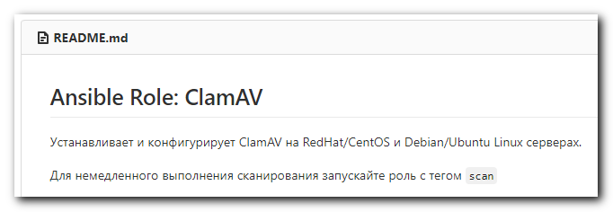

[support@nb2339]# export ANSIBLE_CONFIG=ansible.cfg ; logfile="$(date +%Y%m%d-%H%M).playbook.log.txt" ; ansible-playbook 20210816-1812.clamav.yml -i list_of_hosts --become --extra-vars "ansible_user=unix-ansible ansible_password=$(pass common/linux-unix-ansible) ansible_sudo_pass=$(pass common/linux-unix-ansible) ansible_ssh_common_args='-oStrictHostKeyChecking=no -oPubkeyAuthentication=no -oUserKnownHostsFile=/dev/null'" --tags=scan | tee -a ./output/${logfile}
...
TASK [das/clamav : run test clamscan] ************************************************************************************************Thursday 14 October 2021 18:47:39 +0300 (0:00:02.423) 0:00:10.078 ******
[WARNING]: Consider using 'become', 'become_method', and 'become_user' rather than running sudo
changed: [m1-db10-tst1]

PLAY RECAP ***************************************************************************************************************************m1-db10-tst1 : ok=8 changed=1 unreachable=0 failed=0 skipped=0 rescued=0 ignored=0

Thursday 14 October 2021 18:47:41 +0300 (0:00:02.654) 0:00:12.733 ******
===============================================================================
Gathering Facts --------------------------------------------------------------------------------------------------------------- 4.23s
das/clamav : Ensure a cronjob exist. ------------------------------------------------------------------------------------------ 2.80s
das/clamav : run test clamscan ------------------------------------------------------------------------------------------------ 2.66s
das/clamav : Ensure obsolete cron job absent ---------------------------------------------------------------------------------- 2.42s
das/clamav : conevrt list to var clamscan_run_options ------------------------------------------------------------------------- 0.16s
das/clamav : conevrt list to var freshclam_run_options ------------------------------------------------------------------------ 0.16s
das/clamav : set usage limits ------------------------------------------------------------------------------------------------- 0.13s
das/clamav : fill excluded directories list ----------------------------------------------------------------------------------- 0.13s
[support@nb2339]#

[s.belogrud@nb2339]# git --no-pager diff vars/redhat.yml
diff --git a/vars/redhat.yml b/vars/redhat.yml
index 48c6d8a..a30295b 100644
--- a/vars/redhat.yml
+++ b/vars/redhat.yml
@@ -1,3 +1,5 @@
---
clamav_packages:
- - clamav-0.103.3*
+ - clamav-0.104.*
+
+# - clamav-0.103.3*
[s.belogrud@nb2339]#

[support@nb2339]# export ANSIBLE_CONFIG=ansible.cfg ; logfile="$(date +%Y%m%d-%H%M).playbook.log.txt" ; ansible-playbook 20210816-1812.clamav.yml -i list_of_hosts --become --extra-vars "ansible_user=unix-ansible ansible_password=$(pass common/linux-unix-ansible) ansible_sudo_pass=$(pass common/linux-unix-ansible) ansible_ssh_common_args='-oStrictHostKeyChecking=no -oPubkeyAuthentication=no -oUserKnownHostsFile=/dev/null'" --check --diff | tee -a ./output/${logfile}
...
TASK [das/clamav : Include OS variables] *********************************************************************************************
Thursday 14 October 2021 18:53:46 +0300 (0:00:02.425) 0:00:11.554 ******
ok: [m1-db10-tst1] => (item=/mnt/c/data/work/ansible/gitlab.tcsbank.ru/roles/das/clamav/vars/redhat.yml)

TASK [das/clamav : Ensure specific ClamAV packages are installed.] *******************************************************************
Thursday 14 October 2021 18:53:46 +0300 (0:00:00.106) 0:00:11.661 ******
fatal: [m1-db10-tst1]: FAILED! => changed=false
msg: No package matching 'clamav-0.104.*' found available, installed or updated
rc: 126
results:
- No package matching 'clamav-0.104.*' found available, installed or updated

TASK [das/clamav : Ensure default ClamAV packages are installed.] ********************************************************************
Thursday 14 October 2021 18:53:53 +0300 (0:00:06.905) 0:00:18.567 ******
ok: [m1-db10-tst1]
...

https://www.clamav.net/downloads
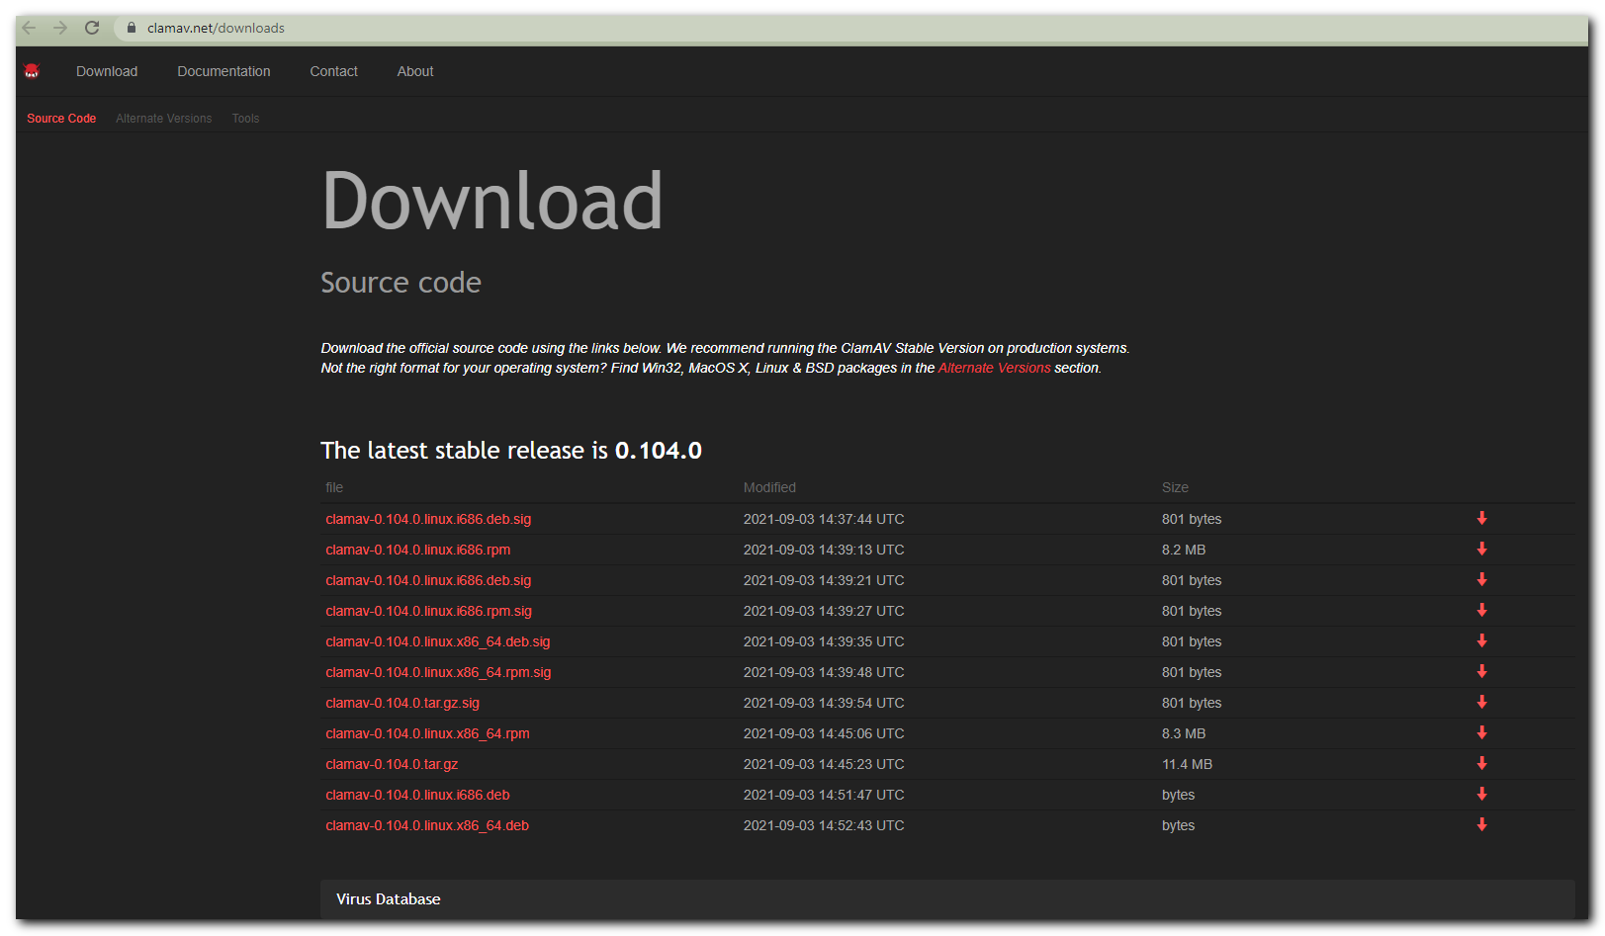

[s.belogrud@nb2339]# scp /drives/c/Users/s.belogrud/Downloads/clamav-0.104.0.linux.x86_64.rpm s_s.belogrud@m1-db10-tst1:/tmp/
clamav-0.104.0.linux.x86_64.rpm 100% 8429KB 4.4MB/s 00:01
[s.belogrud@nb2339]#

[19:09:41 root@m1-db10-tst1 ~]# mkdir -p ~/work/20211014-1910/
[19:10:59 root@m1-db10-tst1 ~]# cp /tmp/clamav-0.104.0.linux.x86_64.rpm ~/work/20211014-1910/
[19:11:05 root@m1-db10-tst1 ~]# yum localinstall ~/work/20211014-1910/clamav-0.104.0.linux.x86_64.rpm
Loaded plugins: langpacks, product-id, search-disabled-repos, subscription-manager
This system is not registered with an entitlement server. You can use subscription-manager to register.
Examining /root/work/20211014-1910/clamav-0.104.0.linux.x86_64.rpm: clamav-0.104.0-1.x86_64
Marking /root/work/20211014-1910/clamav-0.104.0.linux.x86_64.rpm as an update to clamav-0.103.3-8.el7.x86_64
Resolving Dependencies
--> Running transaction check
---> Package clamav.x86_64 0:0.103.3-8.el7 will be updated
---> Package clamav.x86_64 0:0.104.0-1 will be an update
--> Processing Conflict: clamav-filesystem-0.103.3-8.el7.noarch conflicts clamav > 0.103.3-8.el7
--> Finished Dependency Resolution
Error: clamav-filesystem conflicts with clamav-0.104.0-1.x86_64
You could try using --skip-broken to work around the problem
You could try running: rpm -Va --nofiles --nodigest
[19:11:22 root@m1-db10-tst1 ~]#

[19:17:57 root@m1-db10-tst1 ~]# yum list installed clamav*
Loaded plugins: langpacks, product-id, search-disabled-repos, subscription-manager
This system is not registered with an entitlement server. You can use subscription-manager to register.
Installed Packages
clamav.x86_64 0.103.3-8.el7 @tcs-epel
clamav-filesystem.noarch 0.103.3-8.el7 @tcs-epel
clamav-lib.x86_64 0.103.3-8.el7 @tcs-epel
clamav-update.x86_64 0.103.3-8.el7 @tcs-epel
[19:18:08 root@m1-db10-tst1 ~]#

https://tinkoff.slack.com/archives/D8LV2E2S3/p1634227286002600
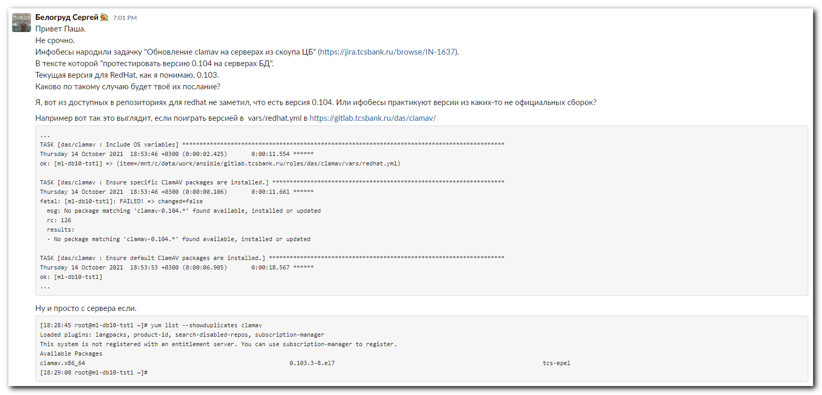

#
# Test: in package installed on redhat or debian systems or no.
#
[support@nb2339]# export ANSIBLE_CONFIG=ansible.cfg ; logfile="$(date +%Y%m%d-%H%M).playbook.log.txt" ; ansible cmd_command -i list_of
_hosts -m shell -a '(which yum 1>/dev/nul 2>&1 && yum list installed clamav ; which apt 1>/dev/nul 2>&1 && apt list --installed clamav 2>/dev/nul) | grep -ie clamav ; echo' --become --extra-vars "ansible_user=s_s.belogrud ansible_password=$(pass common/linux-freeipa) ansible_sudo_pass=$(pass common/linux-freeipa) ansible_ssh_common_args='-oStrictHostKeyChecking=no -oPubkeyAuthentication=no -oUserKnownHostsFile=/dev/null'" | tee -a ./output/${logfile}
m1-db-tst09 | CHANGED | rc=0 >>
clamav.x86_64 0.103.3-1.el7 @tcs-epel
m1-db-tst05 | CHANGED | rc=0 >>
clamav.x86_64 0.101.4-1.el7 @repo-linux.tcsbank.ru_epel_7Server_x86_64_
m1-db-tst11 | CHANGED | rc=0 >>
clamav.x86_64 0.101.2-1.el7 @tcs-epel
m1-db-tst21 | CHANGED | rc=0 >>
clamav.x86_64 0.100.2-2.el7 @repo-linux.tcsbank.ru_epel_7Server_x86_64_Repodata is over 2 weeks old. Install yum-cron? Or run: yum makecache fast
m1-db-tst20 | CHANGED | rc=0 >>
clamav.x86_64 0.100.2-2.el7 @repo-linux.tcsbank.ru_epel_7Server_x86_64_Repodata is over 2 weeks old. Install yum-cron? Or run: yum makecache fast
m1-db-tst29 | CHANGED | rc=0 >>
clamav.x86_64 0.101.4-1.el7 @repo-linux.tcsbank.ru_epel_7Server_x86_64_
m1-db-tst28 | CHANGED | rc=0 >>
clamav.x86_64 0.103.3-1.el7 @repo-linux.tcsbank.ru_epel_7Server_x86_64_
m1-db-tst30 | CHANGED | rc=0 >>
clamav.x86_64 0.103.3-1.el7 @repo-linux.tcsbank.ru_epel_7Server_x86_64_Repodata is over 2 weeks old. Install yum-cron? Or run: yum makecache fast
m1-db-tst31 | CHANGED | rc=0 >>
clamav.x86_64 0.101.2-1.el7 @repo-linux.tcsbank.ru_epel_7Server_x86_64_Repodata is over 2 weeks old. Install yum-cron? Or run: yum makecache fast
m1-db-tst33 | CHANGED | rc=0 >>

m1-db-tst34 | CHANGED | rc=0 >>

[support@nb2339]#

# Move trash to backup folder.
[support@nb2339]# export ANSIBLE_CONFIG=ansible.cfg ; logfile="$(date +%Y%m%d-%H%M).playbook.log.txt" ; ansible cmd_command -i list_of
_hosts -m shell -a 'mkdir -p ~/work/20211015-2214/backup ; for var1 in repo-linux.tcsbank.ru_epel_7Server_x86_64_.repo tcs-rhel-7-server-extras-rpms.repo tcs-rhel-7-server-optional-rpms.repo tcs-rhel-7-server-rpms.repo ; do mv /etc/yum.repos.d/${var1} ~/work/20211015-2214/backup/ ; done' --become --extra-vars "ansible_user=s_s.belogrud ansible_password=$(pass common/linux-freeipa) ansible_sudo_pass=$(pass common/linux-freeipa) ansible_ssh_common_args='-oStrictHostKeyChecking=no -oPubkeyAuthentication=no -oUserKnownHostsFile=/dev/null'" | tee -a ./output/${logfile}
m1-db-tst09 | CHANGED | rc=0 >>
mv: cannot stat '/etc/yum.repos.d/repo-linux.tcsbank.ru_epel_7Server_x86_64_.repo': No such file or directory
m1-db-tst28 | CHANGED | rc=0 >>

m1-db-tst21 | CHANGED | rc=0 >>

m1-db-tst20 | CHANGED | rc=0 >>

m1-db-tst11 | FAILED | rc=1 >>
mv: cannot stat '/etc/yum.repos.d/repo-linux.tcsbank.ru_epel_7Server_x86_64_.repo': No such file or directory
mv: cannot stat '/etc/yum.repos.d/tcs-rhel-7-server-extras-rpms.repo': No such file or directory
mv: cannot stat '/etc/yum.repos.d/tcs-rhel-7-server-optional-rpms.repo': No such file or directory
mv: cannot stat '/etc/yum.repos.d/tcs-rhel-7-server-rpms.repo': No such file or directorynon-zero return code
m1-db-tst29 | CHANGED | rc=0 >>

m1-db-tst30 | CHANGED | rc=0 >>

m1-db-tst31 | CHANGED | rc=0 >>

[support@nb2339]#

# Once again, collect package version if it installed on redhat or debian systems.
[support@nb2339]# export ANSIBLE_CONFIG=ansible.cfg ; logfile="$(date +%Y%m%d-%H%M).playbook.log.txt" ; ansible cmd_command -i list_of_hosts -m shell -a '(which yum 1>/dev/nul 2>&1 && yum list installed clamav ; which apt 1>/dev/nul 2>&1 && apt list --installed clamav 2>/dev/nul) | grep -ie clamav ; echo' --become --extra-vars "ansible_user=s_s.belogrud ansible_password=$(pass common/linux-freeipa) ansible_sudo_pass=$(pass common/linux-freeipa) ansible_ssh_common_args='-oStrictHostKeyChecking=no -oPubkeyAuthentication=no -oUserKnownHostsFile=/dev/null'" | tee -a ./output/${logfile}
m1-db-tst09 | CHANGED | rc=0 >>
clamav.x86_64 0.103.3-1.el7 @tcs-epel
m1-db-tst11 | CHANGED | rc=0 >>
clamav.x86_64 0.101.2-1.el7 @tcs-epel
m1-db-tst05 | CHANGED | rc=0 >>
clamav.x86_64 0.101.4-1.el7 @repo-linux.tcsbank.ru_epel_7Server_x86_64_
m1-db-tst20 | CHANGED | rc=0 >>
clamav.x86_64 0.100.2-2.el7 @repo-linux.tcsbank.ru_epel_7Server_x86_64_
m1-db-tst21 | CHANGED | rc=0 >>
clamav.x86_64 0.100.2-2.el7 @repo-linux.tcsbank.ru_epel_7Server_x86_64_
m1-db-tst29 | CHANGED | rc=0 >>
clamav.x86_64 0.101.4-1.el7 @repo-linux.tcsbank.ru_epel_7Server_x86_64_
m1-db-tst28 | CHANGED | rc=0 >>
clamav.x86_64 0.103.3-1.el7 @repo-linux.tcsbank.ru_epel_7Server_x86_64_
m1-db-tst31 | CHANGED | rc=0 >>
clamav.x86_64 0.101.2-1.el7 @repo-linux.tcsbank.ru_epel_7Server_x86_64_
m1-db-tst30 | CHANGED | rc=0 >>
clamav.x86_64 0.103.3-1.el7 @repo-linux.tcsbank.ru_epel_7Server_x86_64_
m1-db-tst33 | CHANGED | rc=0 >>

m1-db-tst34 | CHANGED | rc=0 >>

[support@nb2339]#

# Install clamav on db-servers. Used special variables for db-servers.
[support@nb2339]# export ANSIBLE_CONFIG=ansible.cfg ; logfile="$(date +%Y%m%d-%H%M).playbook.log.txt" ; ansible-playbook 20210816-1812.clamav.yml -i list_of_hosts --become --extra-vars "ansible_user=s_s.belogrud ansible_password=$(pass common/linux-freeipa) ansible_sudo_pass=$(pass common/linux-freeipa) ansible_ssh_common_args='-oStrictHostKeyChecking=no -oPubkeyAuthentication=no -oUserKnownHostsFile=/dev/null'" --extra-vars '{"clamscan_timeout": "timeout 2h", "clamscan_weekday": "0", "clamscan_hour": "2", "clamscan_minute": "00","clamscan_extra_exclude":["/opt","^/data","^/oramnt","^/mnt"]}' -f 10 | tee -a ./output/${logfile}
...

# After all, there are equal version clamav packages on redhat and debian servers.
[support@nb2339]# export ANSIBLE_CONFIG=ansible.cfg ; logfile="$(date +%Y%m%d-%H%M).playbook.log.txt" ; ansible cmd_command -i list_of_hosts -m shell -a '(which yum 1>/dev/nul 2>&1 && yum list installed clamav ; which apt 1>/dev/nul 2>&1 && apt list --installed clamav 2>/dev/nul) | grep -ie clamav ; echo' --become --extra-vars "ansible_user=s_s.belogrud ansible_password=$(pass common/linux-freeipa) ansible_sudo_pass=$(pass common/linux-freeipa) ansible_ssh_common_args='-oStrictHostKeyChecking=no -oPubkeyAuthentication=no -oUserKnownHostsFile=/dev/null'" | tee -a ./output/${logfile}
m1-db-tst09 | CHANGED | rc=0 >>
clamav.x86_64 0.103.3-8.el7 @tcs-epel
m1-db-tst05 | CHANGED | rc=0 >>
clamav.x86_64 0.103.3-8.el7 @tcs-epel
m1-db-tst11 | CHANGED | rc=0 >>
clamav.x86_64 0.103.3-8.el7 @tcs-epel
m1-db-tst20 | CHANGED | rc=0 >>
clamav.x86_64 0.103.3-8.el7 @tcs-epel
m1-db-tst21 | CHANGED | rc=0 >>
clamav.x86_64 0.103.3-8.el7 @tcs-epel
m1-db-tst28 | CHANGED | rc=0 >>
clamav.x86_64 0.103.3-8.el7 @tcs-epel
m1-db-tst30 | CHANGED | rc=0 >>
clamav.x86_64 0.103.3-8.el7 @tcs-epel
m1-db-tst29 | CHANGED | rc=0 >>
clamav.x86_64 0.103.3-8.el7 @tcs-epel
m1-db-tst31 | CHANGED | rc=0 >>
clamav.x86_64 0.103.3-8.el7 @tcs-epel
m1-db-tst33 | CHANGED | rc=0 >>
clamav/bionic-updates,bionic-security,now 0.103.2+dfsg-0ubuntu0.18.04.2 amd64 [installed]
m1-db-tst34 | CHANGED | rc=0 >>
clamav/bionic-updates,bionic-security,now 0.103.2+dfsg-0ubuntu0.18.04.2 amd64 [installed]
[support@nb2339]#

Oct 18, 2021
https://docs.clamav.net/manual/Installing.html
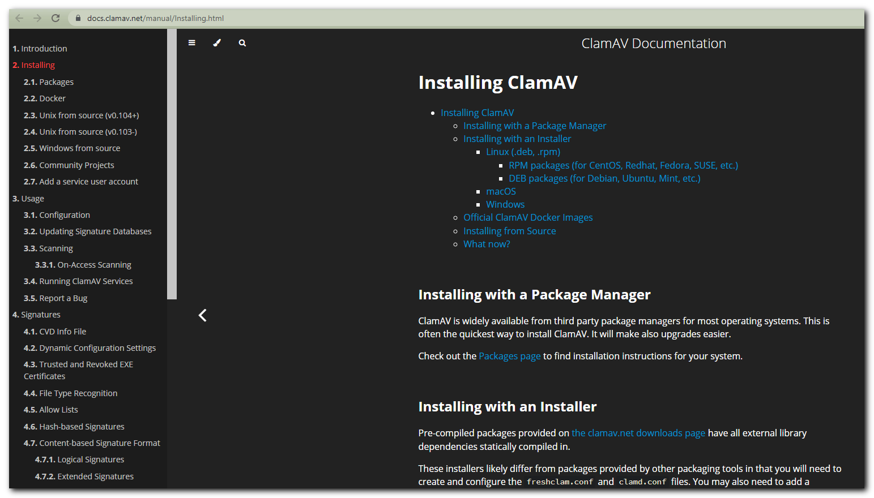

https://www.clamav.net/downloads#collapseRedHat
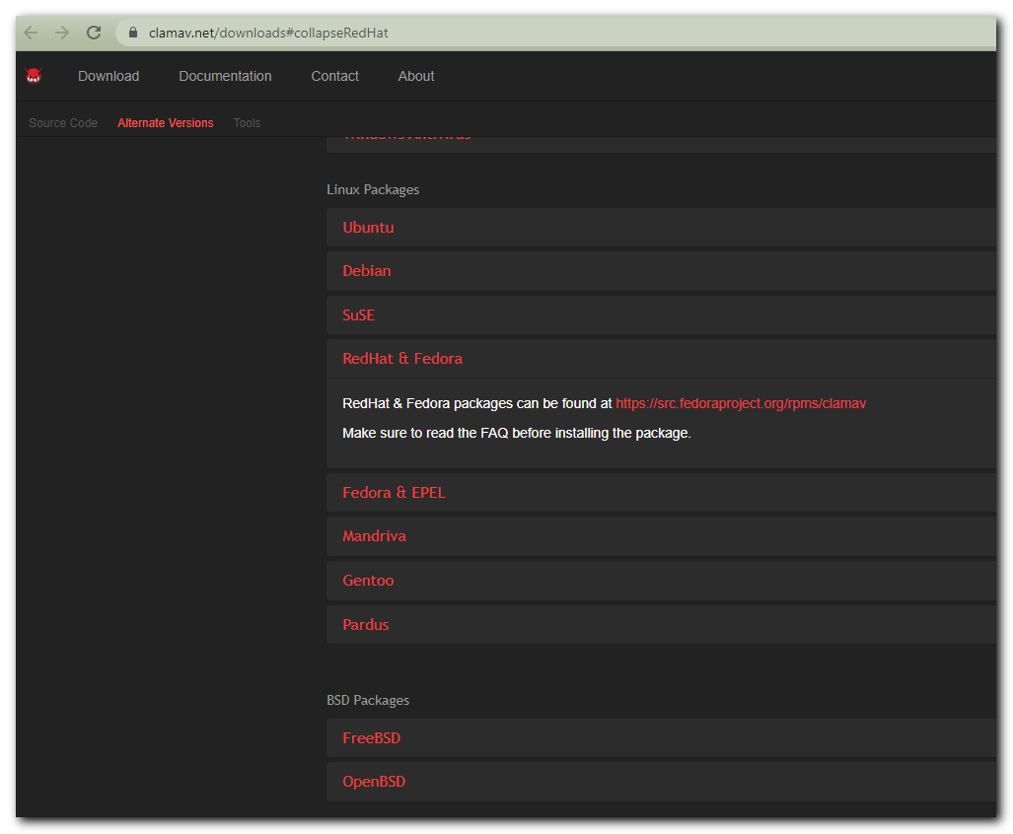
https://www.clamav.net/downloads
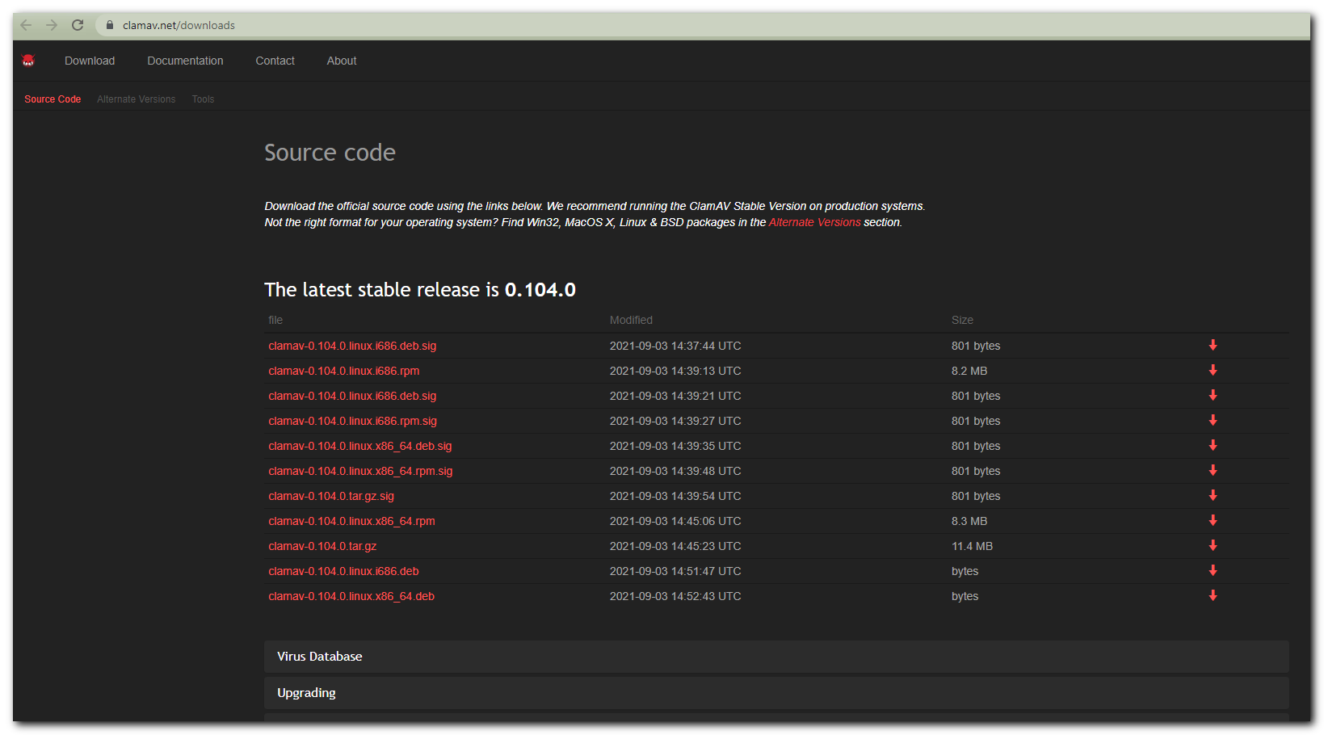

https://docs.fedoraproject.org/en-US/epel/
